Tarnowskie Góry, 29.06.2016

Semester: II
Group: 3

Computer Programming Laboratory

Author: Marek Paśnik
Tutor: Jakub Nalepa

- Task topic
Version control system
A simple version control system – check in, commit, update, diff.

- Project analysis
Program operates on files and directories using structure name trackst (tracklist), which is created, by scanning the current working directory. Program can distinct which objects in directory are files or folders. By using appropriate command, we can add files to the tracklist and if needed commit them to record changes to the repository.

- External specification

The program is called Basic Version Control System and can be only started from command line, in which it could be called to do various things.
Possible commands (which are listed by using -h or help command)

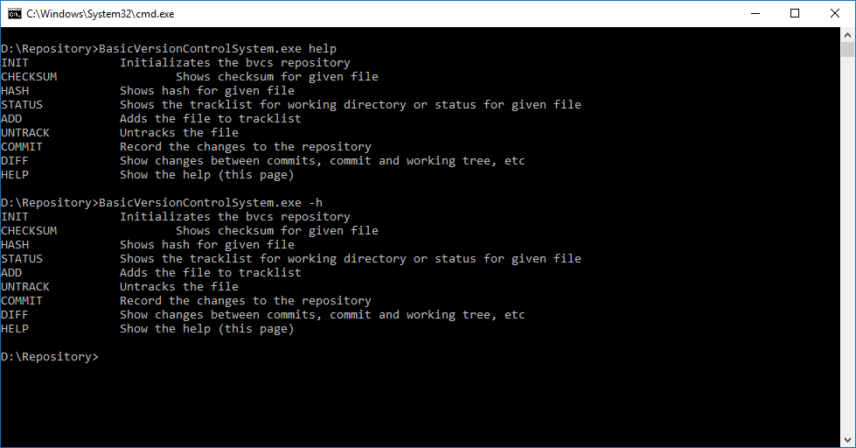

- Testing
For testing purpose, I’ve placed my main program executable in directory called Repository

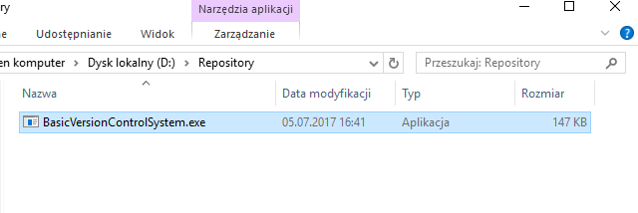
As seen on screenshot the Repository folder is empty, we can initialize our program by command init. After our repository initialization we must provide some informations about our project.
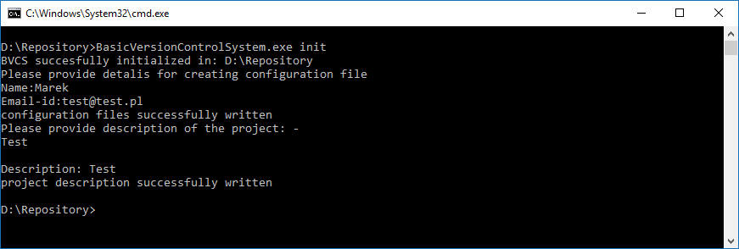
The BVCS is fully initialized and ready to work, now we can add some files to our folder to see how it’s works. The initialization process creates .bvcs where BVCS is storing informations about our files and its configuration.
For testing , 4 files were created index.html , main.cpp and two text files.
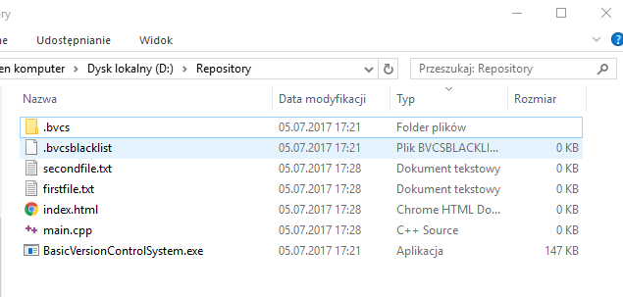
First BVCS need to check status of the files, we can do that by command status.
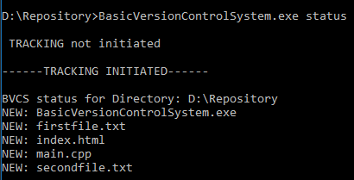

BVCS found our recently created files!
Now we can add our files to tracking list. We can do it manually by command add <filename> or just provide a dot to tell BVCS that we want to add all the files in this directory.
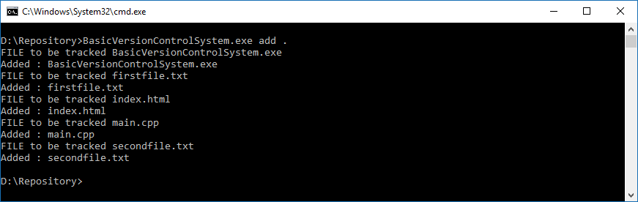
Our files are now tracked, we can see their status using command status
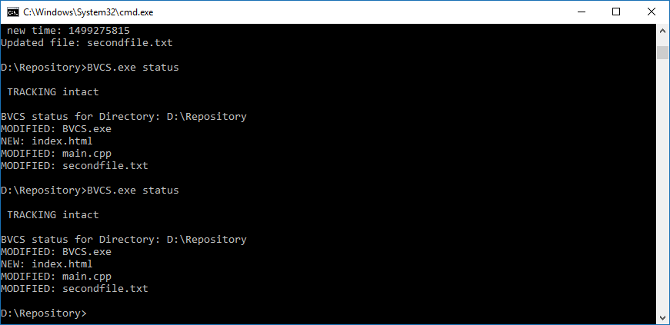

More detailed version (Checksum is 0 because the files are empty):

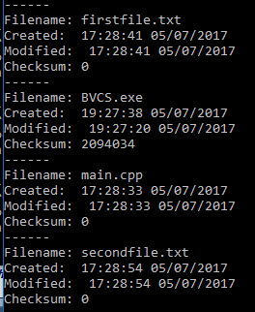

After some changes in files we can commit our changes into repository using command
commit <description>
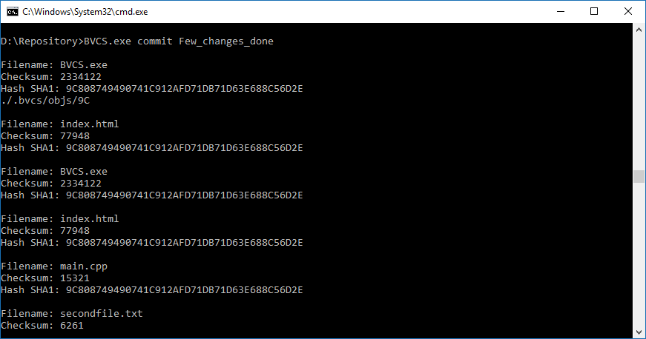
Our commits are stored in log file, in .bvcs /logs directory.

We can also use the diff command, to see the differences between files.
diff <filename> <filename>
